**IMPLEMENTING WEB APPLICATION**

**CREATE UI TO INTERACT WITH APPLICATION**

|  |  |
| --- | --- |
| Team ID | PNT2022TMID09679 |
| Project Name | Nutrition Assistant Application |

# HOME PAGE

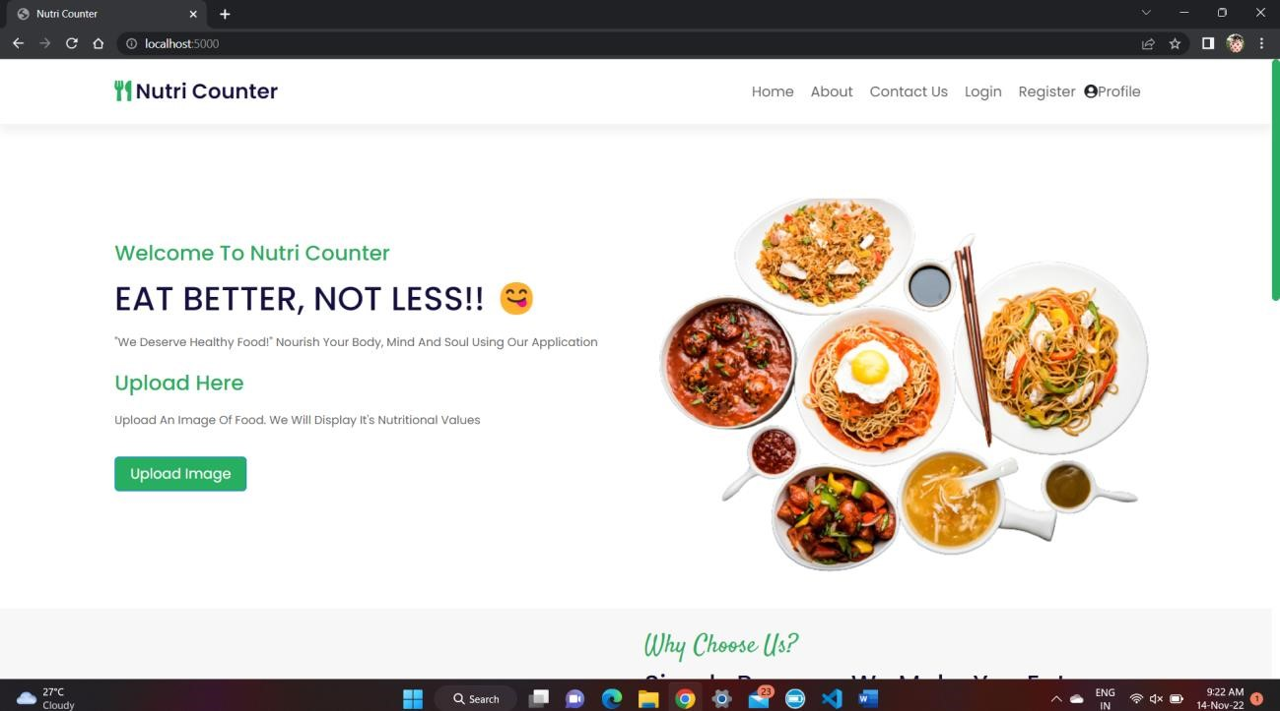

# LOGIN PAGE

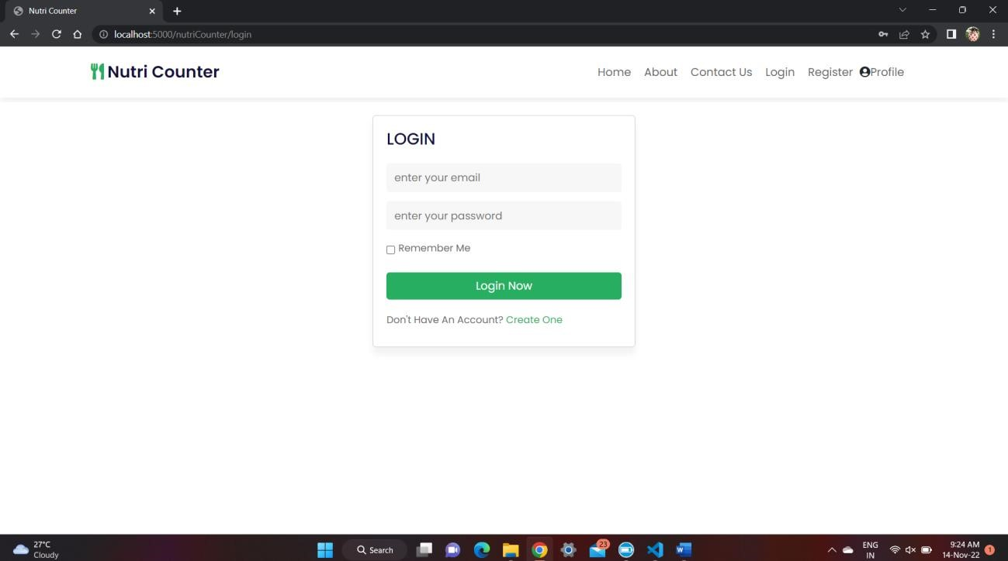

# REGISTRATION PAGE

